-- 1) Monthly sales by country
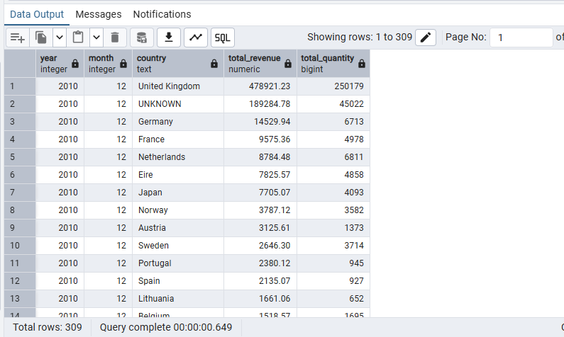
-- 2) Top 10 products by revenue (last 6 months)
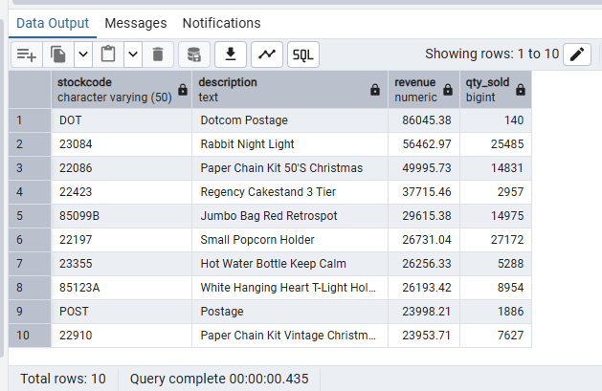
-- 3) Customer Lifetime Value (CLTV)
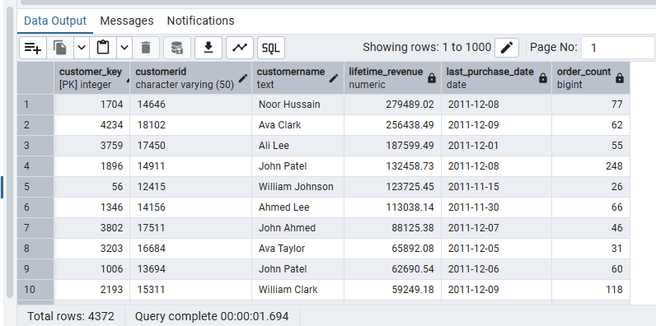
-- 4) Daily revenue trend (last 90 days)
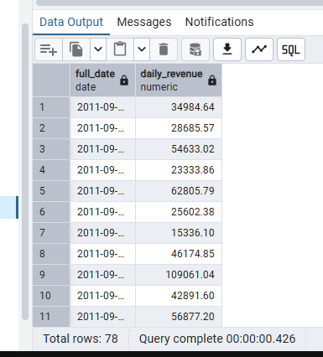
-- 5) Product price vs revenue analysis
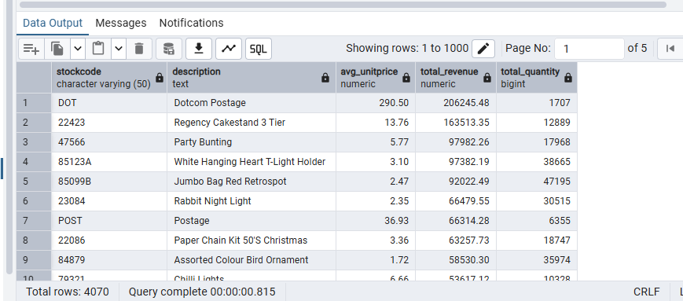
-- 6) Cohort analysis (signup month vs 3-month revenue)
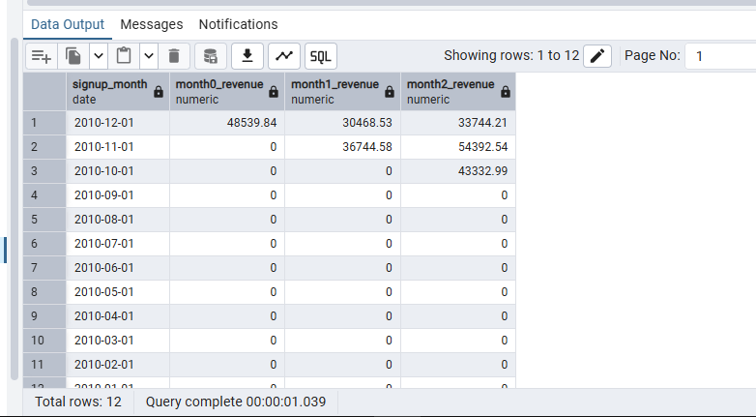

-- 7) OLAP Verification Query (monthly revenue by country)
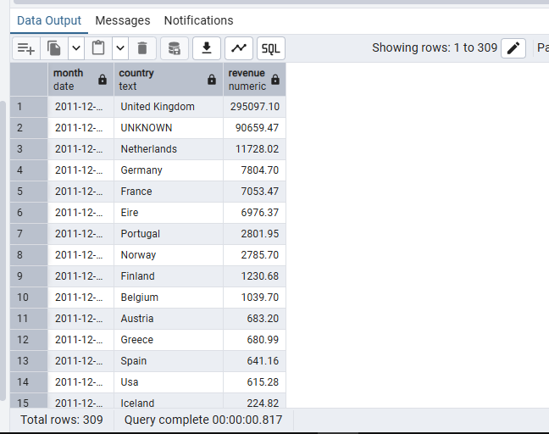

-- Precompute months from dim_date_elt
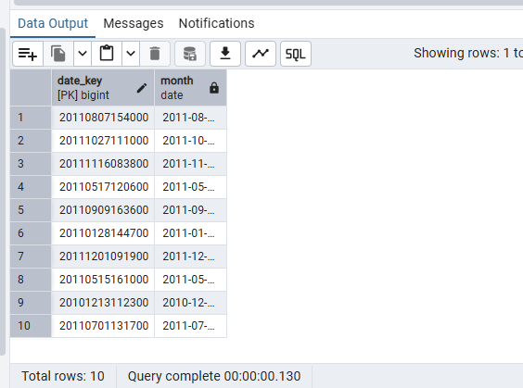

-- MOLAP 1: Monthly revenue by country
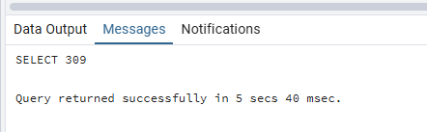
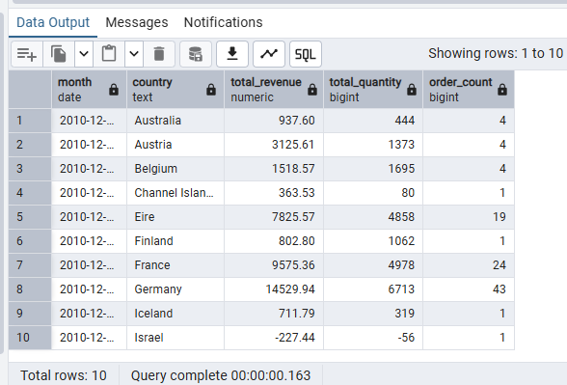

-- MOLAP 3: Customer monthly revenue
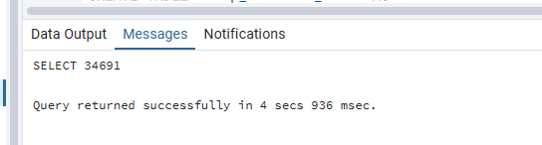
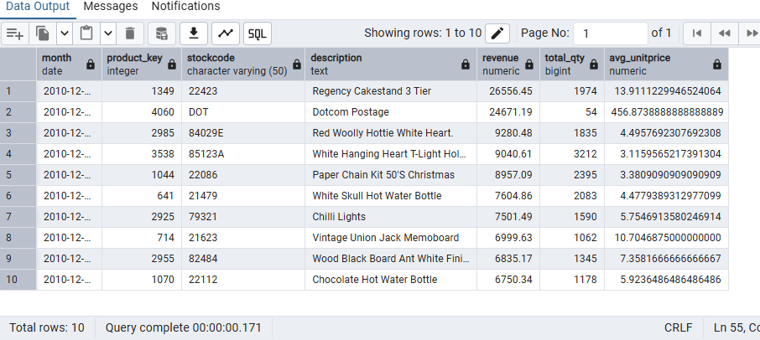

-- MOLAP 3: Customer monthly revenue (only months with sales)
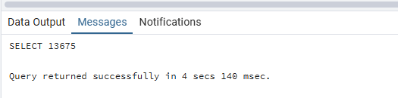
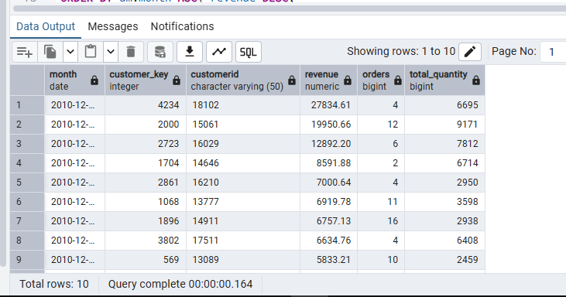

-- MOLAP 4: Top 10 products last 3 months
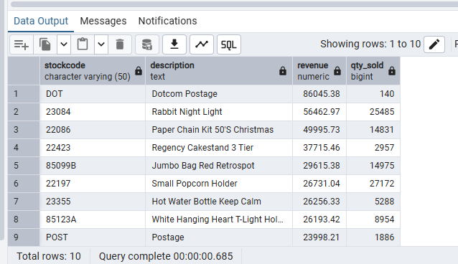
-- MOLAP 5: Daily revenue trend (last 90 days)
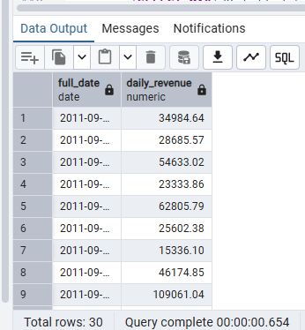
-- MOLAP 6: Cohort analysis (signup month vs 3-month revenue)
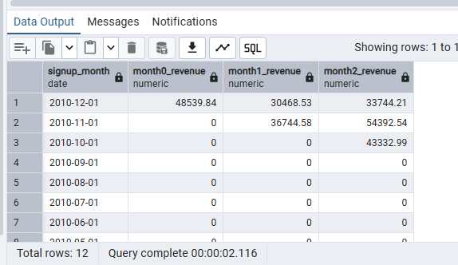
-- MOLAP 7: Verification MOLAP vs OLAP for monthly sales by country
